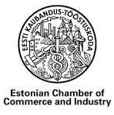 | 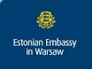 | 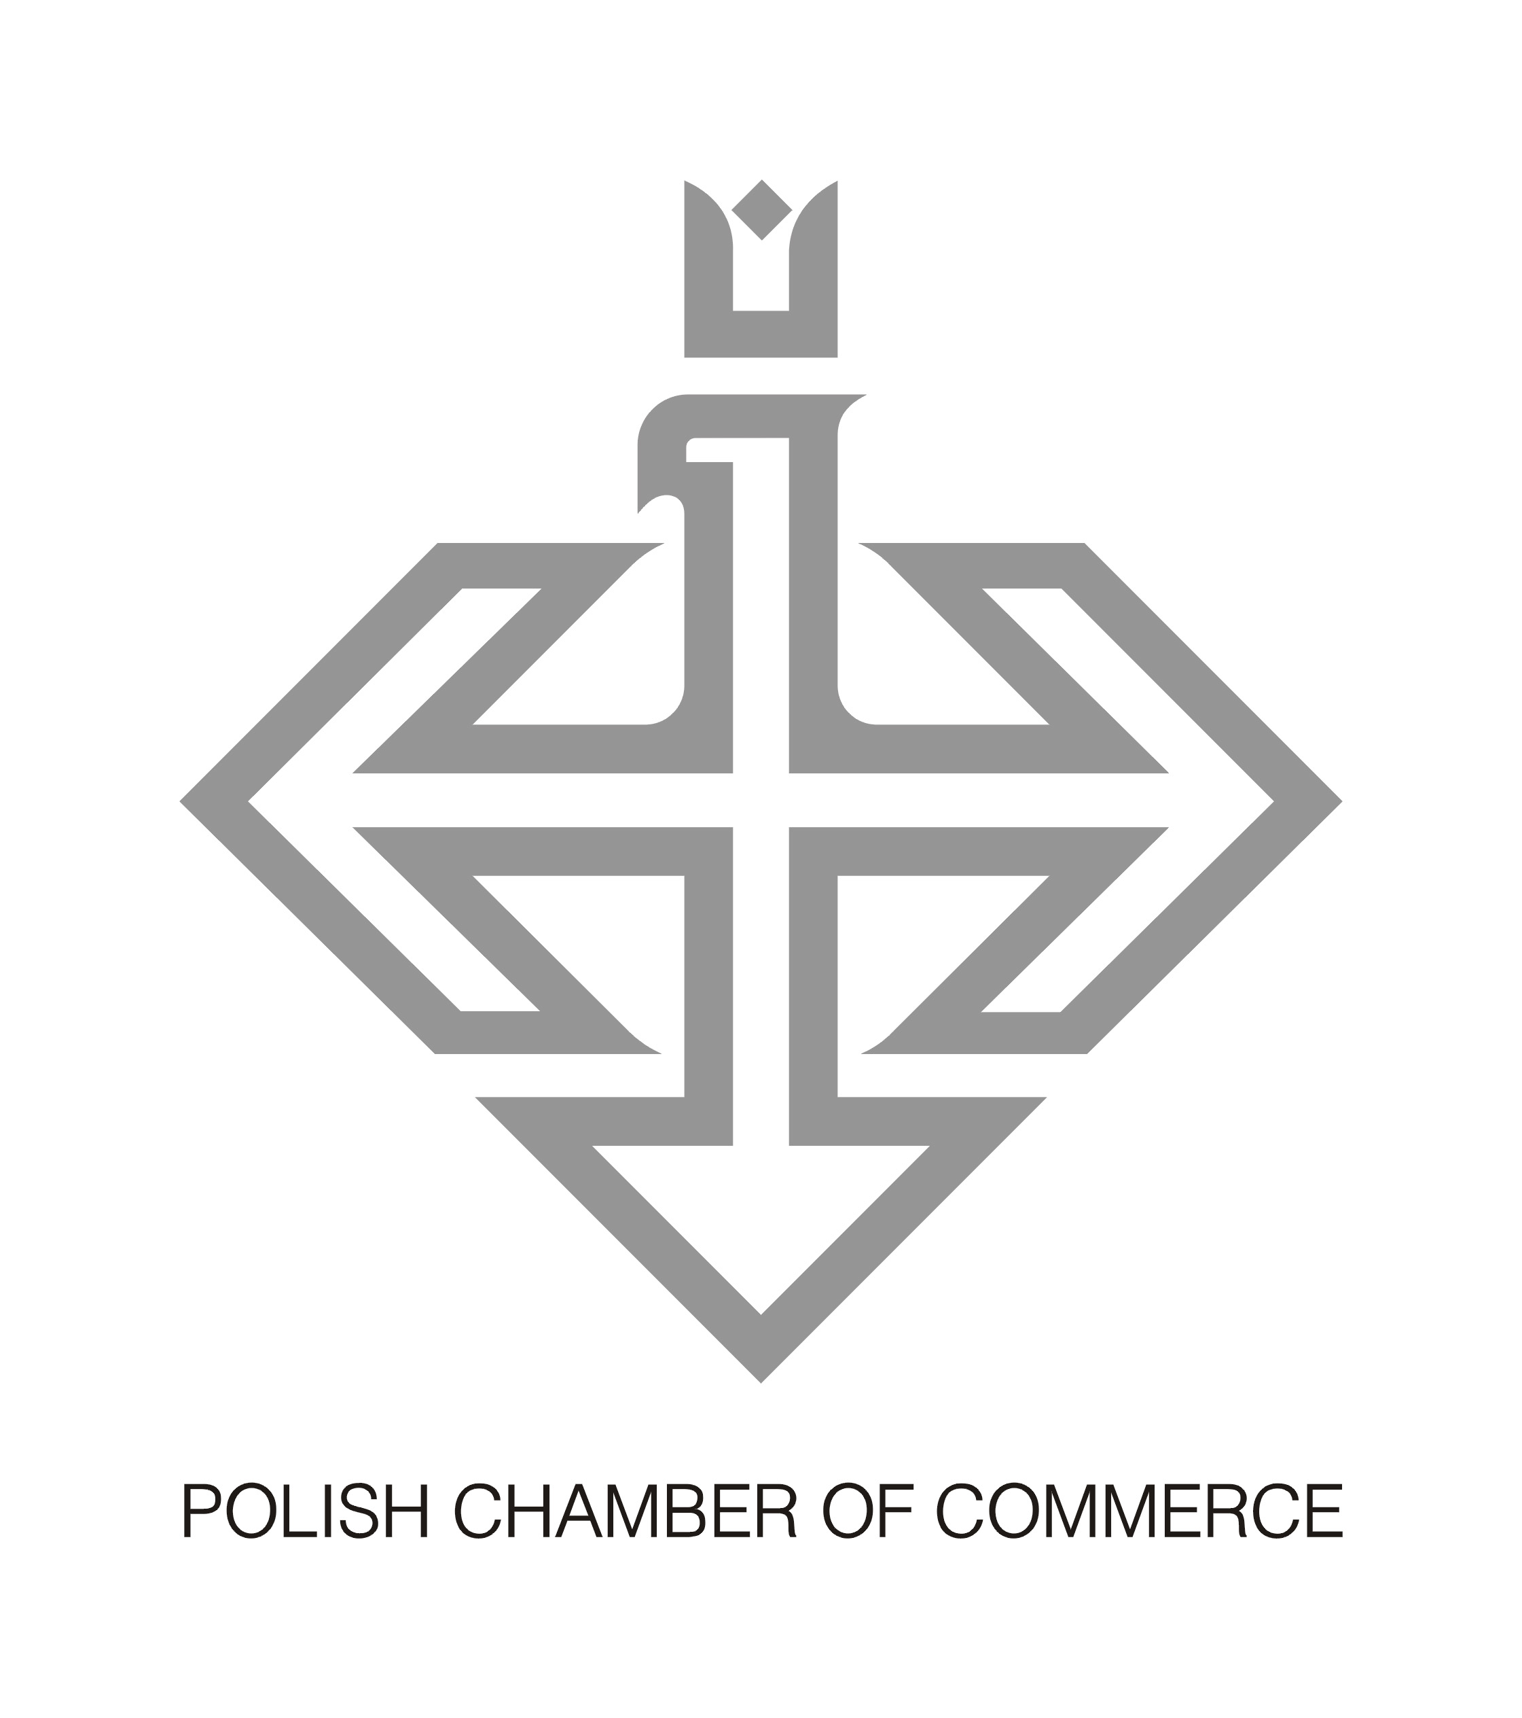

VISIT TO POLAND

Company profiles

1. | Alexela Group AS
Number of employees (2013): | 1570
Scope of activity | Holding company: Main services  In energy field: loading and storage of light and dark oil products, LPG, petrocemichals, gasoline; developement of a regional LNG terminal; oil product trading and retail and wholesale of petrol and diesel fuel. Wholesale of bulk, cylinder and autogas (LPG); oil shale mining, shale oil and gas processing; collection and treatment of waste products, managment of lanfills, road and street cleaning; sale of electricity to retail clients and business.  In metal working industry: Productiona and sale of trailers; sheet metal and tubes laser cutting; surface treatment, painting, assembly, press-forming, punching; Hoh dip galvanizing of steel construction, passivation etc.  In real estate market: Development of real estate in Tallinn, Paldiski and their nearest regions; development of a logistics parks, technology incubators.
Major interest in Polish market and companies | To meet representatives of the Harbour of Gdansk
Representative of the company: | Mr. Heiti Hääl
Position: | CEO
Phone: | +3726154081
E-mail: | heiti@alexela.ee
Website: | www.alexelagroup.eu

2.Name of the company: | Ambient Sound Investments OÜ (ASI)
Number of employees (2013): | ~10
Turnover (EUR, 2012) | assets under management portfolio 90mEUR
Scope of activity | Ambient Sound Investments is an equal partnership by four founding engineers at Skype Technologies.  As the partners are investing their own money, ASI is not a fund, it's more as a family trust than a typical venture capital firm.  Ambient Sound Investments portfolio consists of approximately 30 companies which are located in Europe (Finland, England, France, Israel, Estonia), US and Asia (Singapore, Chna, Japan, Hong Kong)
Major interest in Polish market and companies | Skype's four Estonian founding engineers investment company is looking for technology start-ups and private equity investment opportunities in Poland  We would like to meet investors of venture capital and private equity, national invetment structures.  Obtain information of national measures of development about the venture capital market.  Obtain general information about the business environment.
Representative of the company: | Mr. Margus Uudam
Position: | Head of Venture Capital Investments
Phone: | +372 5028850
E-mail: | info@asi.ee
Website: | www.asi.ee

3. | CHEMI-PHARM AS
Number of employees (2013): | 33
Turnover (EUR, 2012) | 1 827 092 EUR
Scope of activity | Chemi-Pharm AS is developing, producing and selling allergen-free disinfection agents, cleaning and maintenance products and 100% natural luxury cosmetics. Totally new approach in cosmetics – the plant derived stem cells extract which has strong cell rejuvenating properties.  Disinfectants and cleaning agents are mainly sold to medical institutions, dental offices, family doctor offices, schools, kindergartens, food industry companies, cleaning companies, sports centers, spas, etc.  Cosmetical brands Domina Elegans and Dominus For Men are sold in beauty chains as well as in small beauty-shops and pharmacies.  The company follows international quality standards ISO 9001, ISO 14001 and ISO 13485 and in 2012 obtained a Certification of European Corporate Social Responsibility Award.  Export forms currently more than 50% of total turnover. The main export partners are Latvia, Lithuania, Russia, Poland, Sweden, Ukraine, Austria, Malaysia, Finland, Romania, Slovenia, Norway, Singapore, Indonesia.
Major interest in Polish market and companies | The main focus and goal of the visit is to find/meet major distributors or partners or large retail chains representatives (owners) in Poland for the cosmetic brands Domina Elegans and Dominus For Men.  To see cosmetic production.  To have information about the competitive environment, legislative environment (incl. requirements for registrations)
Representative of the company: | Dr. Mrs. Ruth Oltjer
Position: | General Manager, CEO
Phone: | +372 5058313
E-mail: | ruth@chemi-pharm.com
Skype: | ruth_oltjer
Website: | www.chemi-pharm.com

4. | Delux OÜ
Number of employees (2013): | 250
Turnover (EUR, 2012) | 2012 - 17 mil/2013 – 21 mil
Scope of activity | Delux OÜ is producing continental beds ca 2500 complete bedsets 180x200 cm per month, pillows ca 260.000 pcs per month and quilts (polyester fill) ca 50.000 per month. We could offer middle and upper pricelevel.  Our costumers are in Sweden Krueger & Höffner Sweden and JYSK.
Major interest in Polish market and companies | The main focus and goal of the visit is to find/meet retail store chains representatives (owners) in Poland for the pillows and quilts.
Representative of the company: | Mr. Göran Sjöholm
Position: | CEO
Phone: | +372 5394 2511
E-mail: | Goran.sjoholm@delux.ee
Website: | www.delux.ee

5. | ECOMETAL AS
Number of employees (2013): | 56
Turnover (EUR, 2012) | 22 mln EUR
Scope of activity | Recycling of used lead batteries. Production of lead and lead alloys, polypropylene granules, sodium sulfate – all from the recycled lead batteries.  Most modern lead battery recycling plant in Eastern  EU with 10 year business experience, good quality product and service provider to its customers and suppliers.
Major interest in Polish market and companies | Information about the rules of the scrap battery collection in the country and implementation of these rules.  Understanding of the legal aspects of hazardous waste collection and handling system in Poland. Meeting with export-import partners.  To meet Environmental Agency representative who is responsible for the hazardous waste management in Poland including lead acid batteries.
Representative of the company: | Mr. Tõnis Kaasik
Position: | President
Phone: | +3723929121
E-mail: | ecometal@ecometal.ee
Website: | www.ecometal.ee

6. | Eesti Viljasalv AS
Number of employees (2013): | 11
Turnover (EUR, 2013) | 50 000 000
Scope of activity | Trading of proteins, grains, vegetable oils and buy products from Kazakhstan, Russia, Ukraine and Baltic States.
Major interest in Polish market and companies | Information about the import potential of the feed raw materials and vegetable oils to Poland from CIS countries.  Development of business contacts in Poland. To meet importers and exporters of protein additives, vegetable oils, biomass. Representatives of agricultural sector and industry related to agriculture.
Representative of the company: | Mr. Tõnis Leetjõe
Position: | CEO/Partner
Phone: | +372 50 92 358
E-mail: | tonis@eviljasalv.ee
Skype: | tonis.leetjoe
Website: | www.eviljasalv.ee

7. | Estonian Forest and Wood Industries Association
Number of employees (2013): | 5
Turnover (EUR, 2012) | 880 000 000€
Scope of activity | Non-profit umbrella organisation that represents the best interests of its 58 registered members. The members combined turnover is approximately 65% of the combined total of the entire wood and forest sector.  We provide an open B2B doorway to making contact with our members who are interested in determing how to increase their market performance in Poland.
Major interest in Polish market and companies | To meet potential new clients and B2B partners.  Seeking to meet agents responsible for the procurement of wholesale timber products, such as sawn material, glulam, particle board and plywood  We would like a comprehensive overview of companies that focus on the wood and forest industry.
Representative of the company: | Mr. Erik Konze
Position: | Consultant
Phone: | +372 501 9079
E-mail: | erik.konze@empl.ee
Website: | www.empl.ee

8. | Olympic Entertainment Group AS
Number of employees (2013): | 2534
Turnover (EUR, 2012) | 135,9 M
Scope of activity | Olympic Entertainment Group AS with its subsidiaries is the leading provider of gaming services in the Baltic States. The Group operates in Estonia, Latvia, Lithuania, Poland, Belarus, Slovakia and Italy.
Major interest in Polish market and companies | To find new hotel, entertainment and business contacts. Increase of Olympic Casino in Poland.
Representative of the company: | Mr. Armin Karu
Position: | Chairman of the Board
Phone: | +3726671250
E-mail: | armin.karu@oc.eu
Website: | http://www.olympic-casino.com/  https://www.olybet.com/

9. | Rait AS
Number of employees (2013): | 125
Turnover (EUR, 2012) | 20 Mil EUR
Scope of activity | RAITWOOD brand specialises in production of planed finishing materials from Nordic softwood species (Picea Abies, Pinus Sylvestris) with 23 years of experience of exporting to over 30 countries worldwide.  - wall panelling,  - decking,  - flooring,  - four-sides-planed wood
Major interest in Polish market and companies | - Establish new contacts with Polish manufacturers using planed (profiled) softwood (spruce or pine) in their processing (house producers, garden shed manufacturers other wood processing industries) and regional resellers specialising in selling wood to the building sector ;  - support existing business relationships in Poland;  - create better understanding of Polish market  Receive information of volume of wood production and consumption (in general and specifically in building sector, regional distribution of wood processing enterprises; level of building activity (private dwellings)
Representative of the company: | Mr. Ivar Dembovski
Position: | Chairman of the Board
Phone: | +372 50 56765
E-mail: | ivar.dembovski@raitwood.ee
Website: | www.raitwood.com

10. | SANGAR AS
Number of employees (2013): | 210
Turnover (EUR, 2012) | 4400000
Scope of activity | We create and sell high quality shirts, blouses, ties and accessories
Major interest in Polish market and companies | To find contacts for opening our web-shop in Poland and selling in local web-stores.
Representative of the company: | Mr. Gunnar Kraft
Position: | Chairman of the Board
Phone: | +3725042145
E-mail: | Gunnar.kraft@sangar.ee
Website: | www.sangar.ee

Name of the company: | Tark Grunte Sutkiene
Number of employees (2013): | over 100 in the Baltics
Turnover (EUR, 2012) | around 7.5 million euros in the Baltics
Scope of activity | TARK GRUNTE SUTKIENE is a leading full-service commercial law firm in Baltic States. We have a team of over 100 lawyers, including 19 partners, working in 4 offices and serving clients in 9 languages. Our strategic partner is Vlasova Mikhel & Partners, a largest law firm in Belarus.  One of the oldest and leading law firms in the Baltics; wide international recognition; covering all areas of law; strategic partner for high end clients worldwide.
Major interest in Polish market and companies | We would like to meet entrepreneurs who need legal assistance in the Baltics and introduce our legal services to the business community in Poland.
Representative of the company: | Mr. Aare Tark
Position: | Managing Partner
Phone: | +372 6110 900, mobile: +372 50 37 391
E-mail: | aare.tark@tgslegal.com
Website: | www.tarkgruntesutkiene.com

11. | VARUL (Lithuania)
Number of employees (2013): | 30 (Lithuania), 90 in the Baltics in total i.e. in Estonia, Latvia and Lithuania
Scope of activity | VARUL has offices in Tallinn, Tartu, Riga and Vilnius and employs a total of about 90 attorneys and lawyers. The firm is focused on advising both domestic and international clients on all aspects of business law.
Major interest in Polish market and companies | To meet an international business law firms in Poland that would have interests in the Baltics.  Receive general market figures information.
Representative of the company: | Mr. Robert Juodka, MBA MRICS
Position: | Managing Partner, Attorney-at-Law
Phone: | tel +370 5 248 7337  mob +370 686 26707  fax +370 5 248 7338
E-mail: | robert.juodka@varul.com
Website: | www.varul.com

